Newsletter Content and Graphics

While these images and content are presented in pairs, each image is designed to accompany any of the text options.

Newsletter Image | Newsletter Content
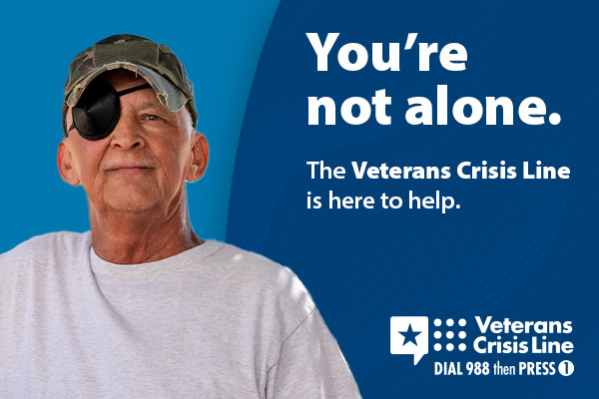 | No Veteran should go through a crisis alone. If you or a Veteran you know needs immediate support, Dial 988 then Press 1.  For more information, visit VeteransCrisisLine.net.
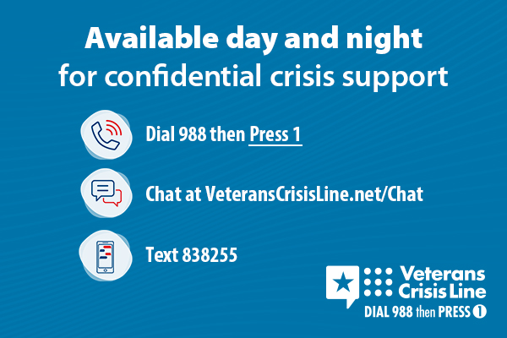 | No matter when you served, no matter what you’re going through, the Veterans Crisis Line is available 24 hours a day, 7 days a week.  For more information, visit VeteransCrisisLine.net.
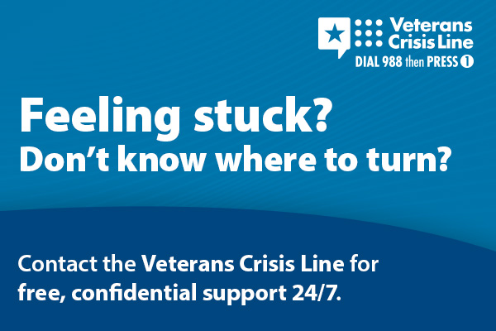 | Responders at the Veterans Crisis Line are ready to listen. You don’t have to be enrolled in VA benefits or health care to receive the support you earned.  Learn more at VeteransCrisisLine.net.
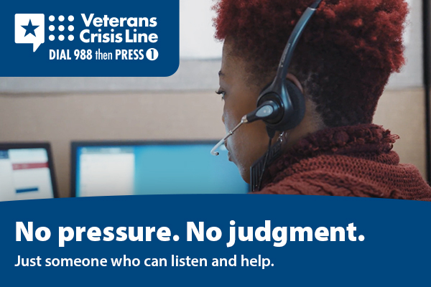 | The Veterans Crisis Line provides a safe and supportive space for all Veterans and their loved ones.  Learn more at VeteransCrisisLine.net.
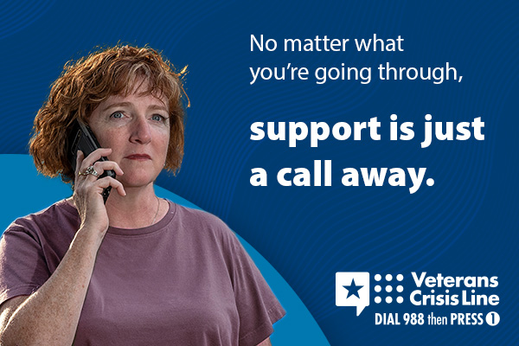 | Relationship stress. Financial pressure. Health issues. Whatever crisis you may face, contact the Veterans Crisis Line. Support is available day or night.  For more information, visit VeteransCrisisLine.net.

