Social Media Content and Graphics

Facebook Copy | X Copy | Instagram Copy | Media Asset
Asking a Veteran if they are having thoughts of suicide might feel daunting, but it won't give them the idea or increase their risk. Be the one to start the conversation—it might save a life.  Looking for the words to say? Start here: VeteransCrisisLine.net/CrisisConversationHandout. | Asking a #Veteran if they are having thoughts of suicide might feel daunting, but it won't give them the idea or increase their risk. Be the one to start the conversation—it might save a life.  Looking for the words to say? Start here: VeteransCrisisLine.net/CrisisConversationHandout. | Asking a #Veteran if they are having thoughts of suicide might feel daunting, but it won't give them the idea or increase their risk. Be the one to start the conversation—it might save a life.  Looking for the words to say? Start here: VeteransCrisisLine.net/CrisisConversationHandout.  #SuicidePrevention #SuicideAwareness | Facebook/X  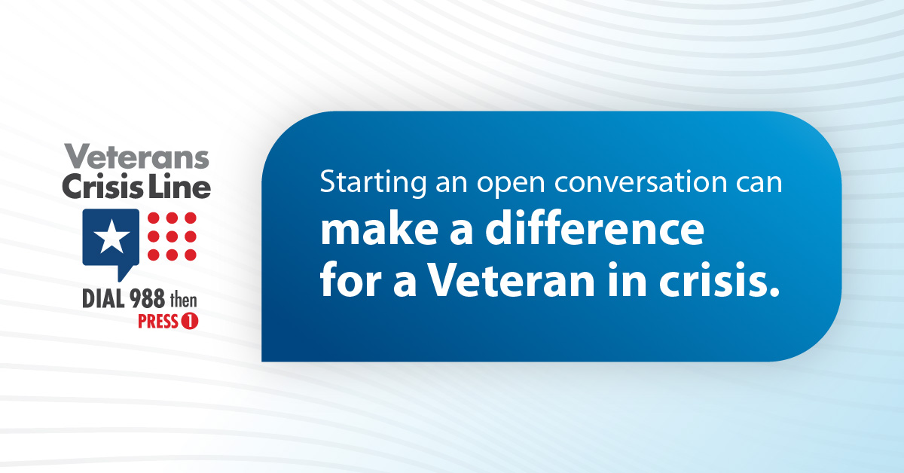  Instagram  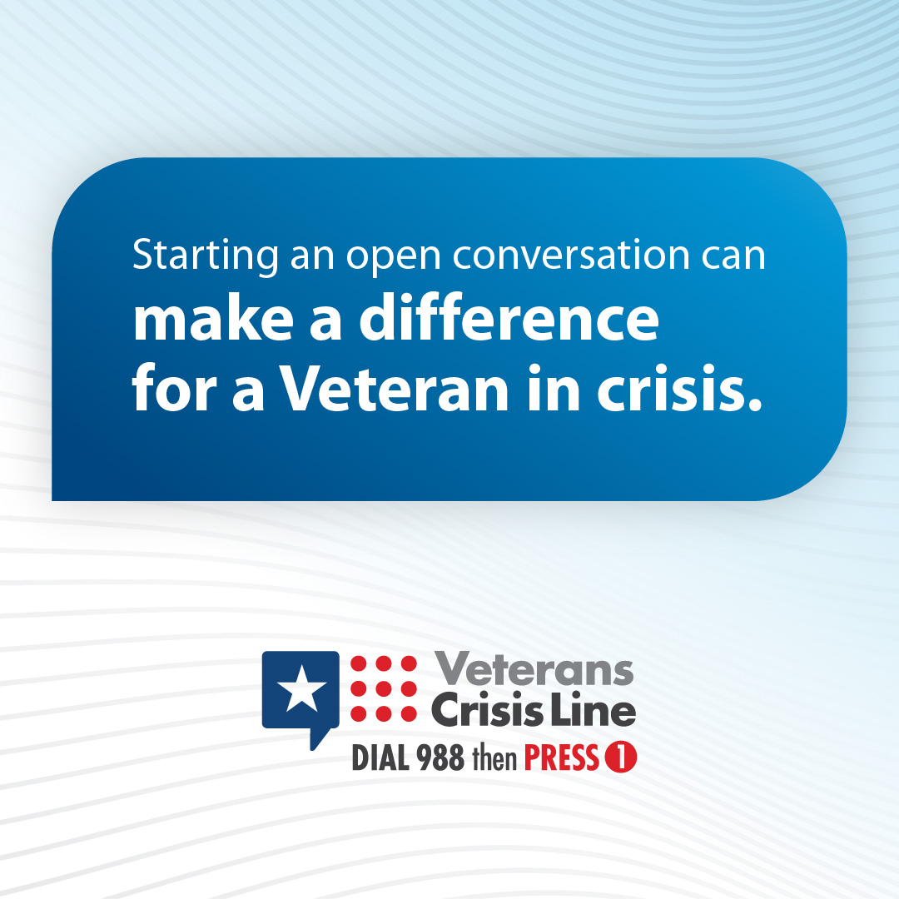
Many Veterans may not show obvious signs of suicide but some of their actions, words, and behaviors might indicate they need help.  Learn what to look for to help the Veterans you know who may be going through a difficult time: VeteransCrisisLine.net/signs-of-crisis. | Many #Veterans may not show obvious signs of suicide, but some of their actions, words, and behaviors might indicate they need help.  Learn what to look for to help the Veterans you know who may be going through a difficult time: VeteransCrisisLine.net/signs-of-crisis. | Many #Veterans may not show obvious signs of suicide, but some of their actions, words, and behaviors might indicate they need help.  Learn what to look for to help the Veterans you know who may be going through a difficult time: VeteransCrisisLine.net/signs-of-crisis.  #SuicidePrevention #SuicideAwareness | Facebook/X  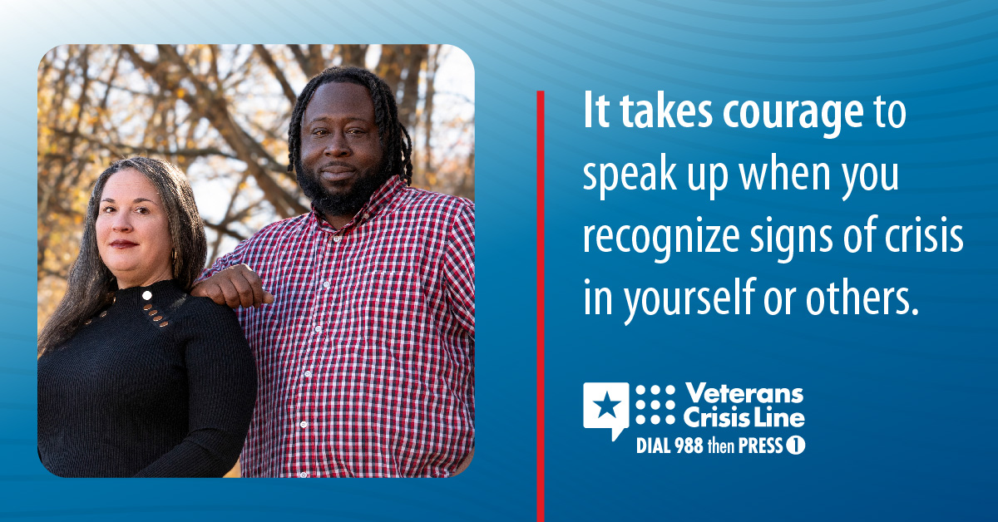  Instagram  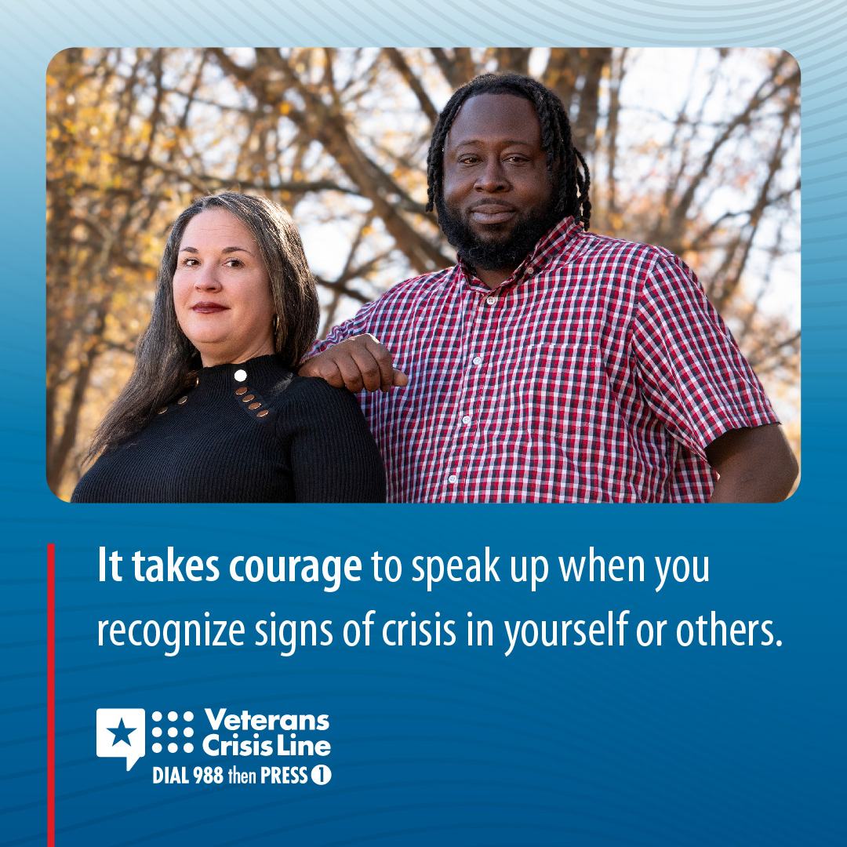
Recognizing suicide warning signs, in yourself or Veterans you care about, can help you take action to ask for support.  Learn more at: VeteransCrisisLine.net/signs-of-crisis. | Recognizing suicide warning signs in yourself or #Veterans you care about can help you take action to ask for support.  Learn more at: VeteransCrisisLine.net/signs-of-crisis. | Recognizing suicide warning signs in yourself or #Veterans you care about can help you take action to ask for support.  Learn more at: VeteransCrisisLine.net/signs-of-crisis.  #SuicidePrevention #SuicideAwareness | Facebook/X  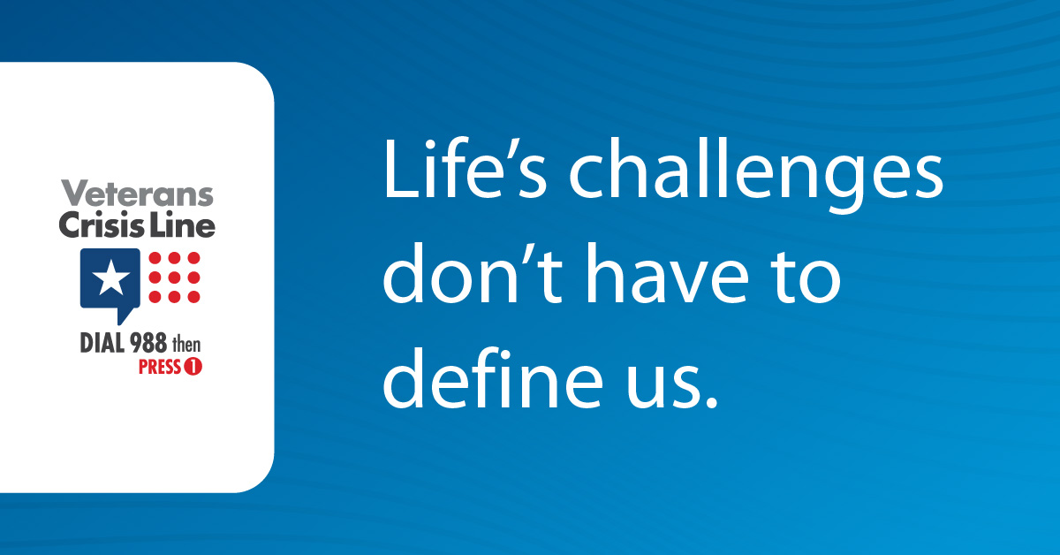  Instagram  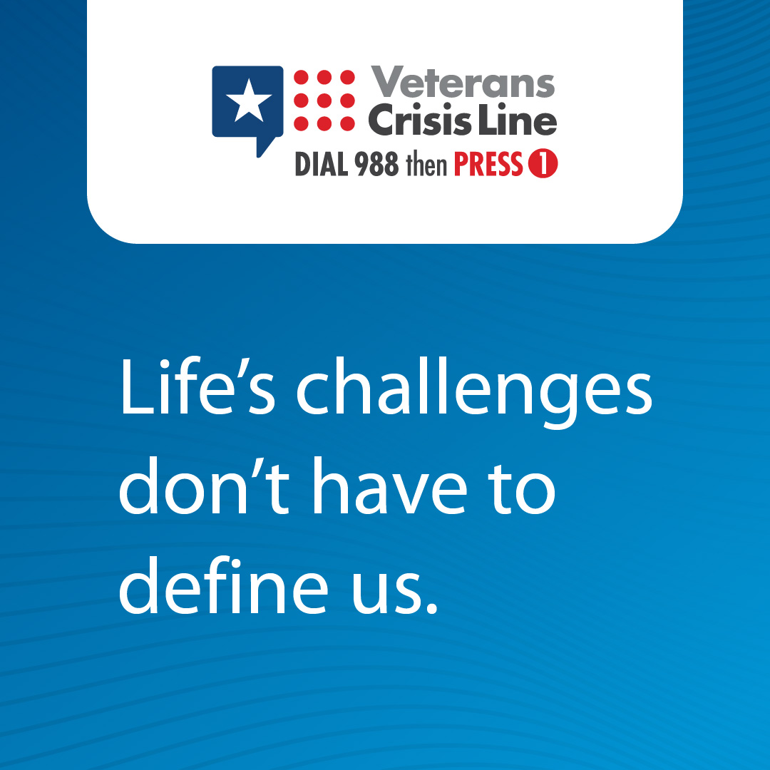
If a #Veteran you know is going through a crisis, make sure they know the #VeteransCrisisLine is available 24/7. You can even call together.  Dial 988 then Press 1, chat at VeteransCrisisLine.net/Chat, or text 838255. | If a #Veteran you know is going through a crisis, make sure they know the #VeteransCrisisLine is available 24/7. You can even call together.  Dial 988 then Press 1, chat at VeteransCrisisLine.net/Chat, or text 838255. | If a #Veteran you know is going through a crisis, make sure they know the #VeteransCrisisLine is available 24/7. You can even call together.  Dial 988 then Press 1, chat at VeteransCrisisLine.net/Chat, or text 838255.  #SuicidePrevention #SuicideAwareness | Facebook/ X  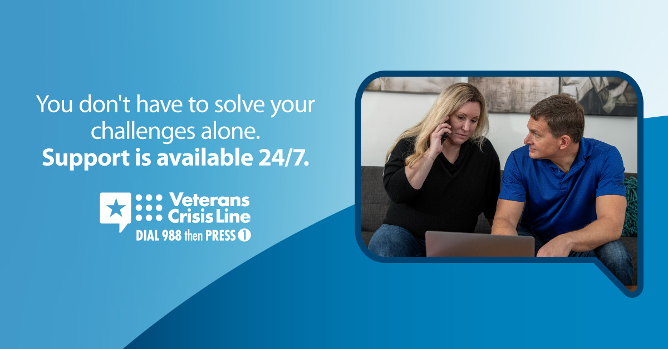  Instagram  
You matter and with the right help, things can get better. The Veterans Crisis Line offers support to all Veterans and their loved ones, day or night.  Reach out today:  Dial 988 then Press 1, chat at VeteransCrisisLine.net/Chat, or text 838255. | You matter and with the right help, things can get better. The #VeteransCrisisLine offers support to all Veterans and their loved ones, day or night.  Reach out today:  Dial 988 then Press 1, chat at VeteransCrisisLine.net/Chat, or text 838255. | You matter and with the right help, things can get better. The #VeteransCrisisLine offers support to all Veterans and their loved ones, day or night.  Reach out today:  Dial 988 then Press 1, chat at VeteransCrisisLine.net/Chat, or text 838255.  #SuicidePrevention #SuicideAwareness | Facebook/ X    Instagram  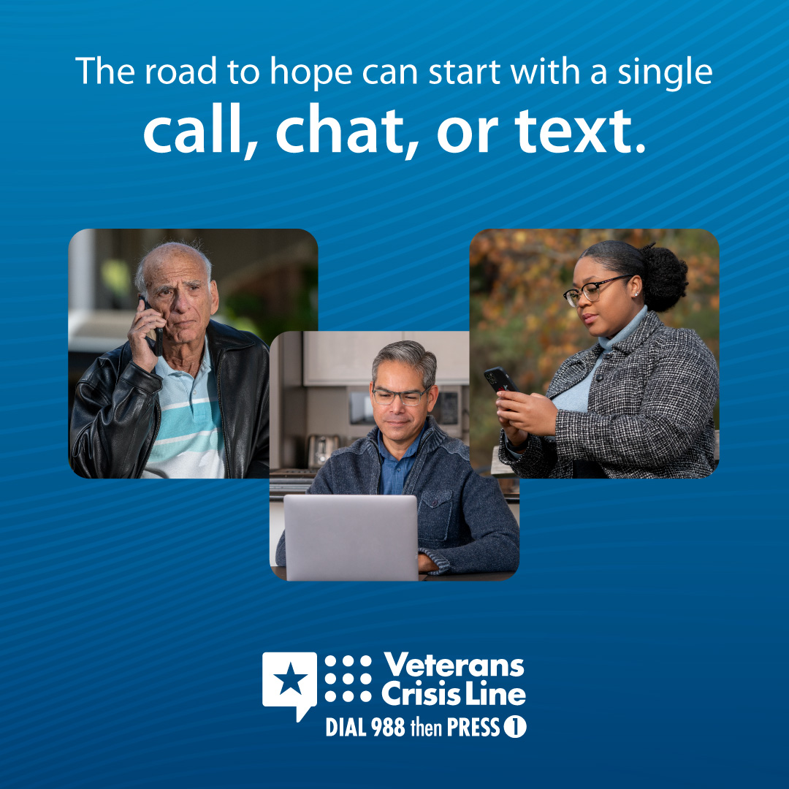
When asking someone if they’re having thoughts of suicide, it’s OK to be direct. Showing genuine care and concern is what really matters.  Get more tips on how to talk about suicide: VeteransCrisisLine.net/CrisisConversationHandout. | When asking someone if they’re having thoughts of suicide, it’s OK to be direct. Showing genuine care and concern is what really matters.  Get more tips on how to talk about suicide: VeteransCrisisLine.net/CrisisConversationHandout. | When asking someone if they’re having thoughts of suicide, it’s OK to be direct. Showing genuine care and concern is what really matters.  Get more tips on how to talk about suicide: VeteransCrisisLine.net/CrisisConversationHandout.  #SuicidePrevention #SuicideAwareness | Facebook/X  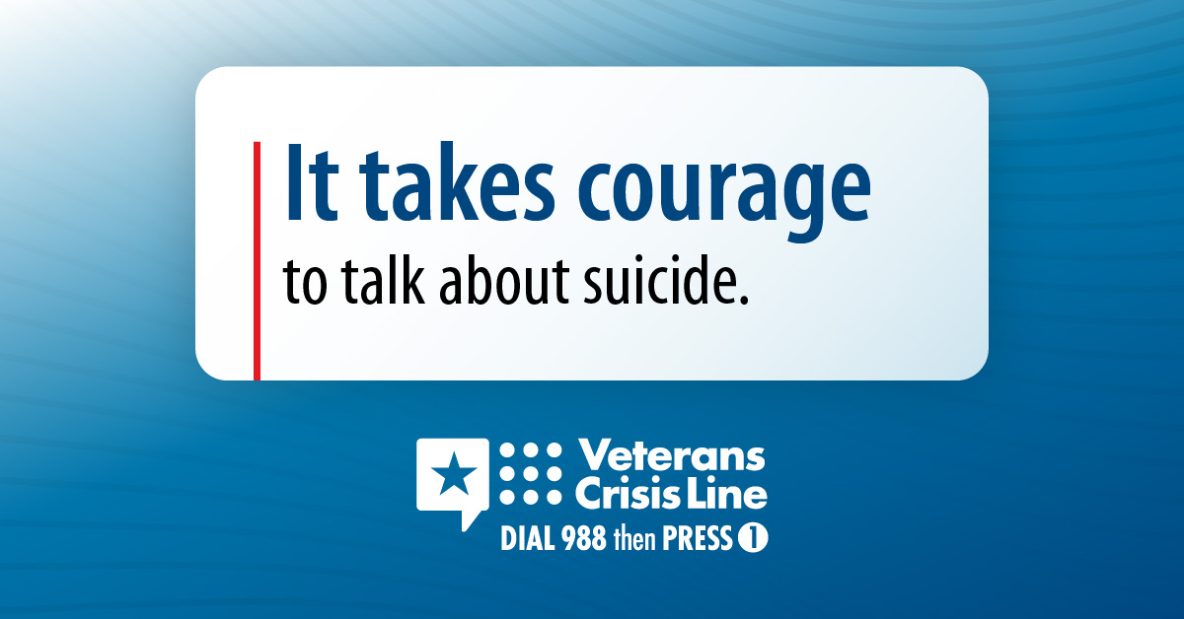  Instagram  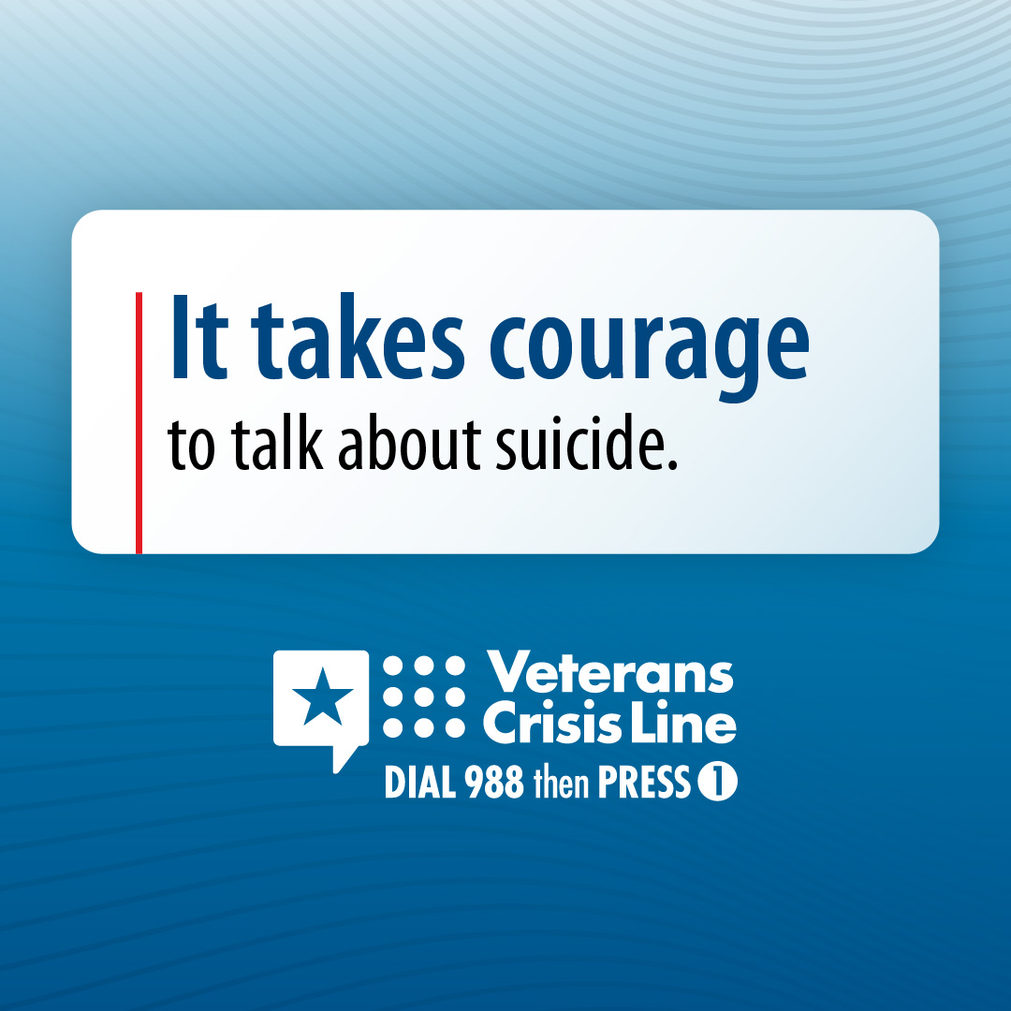
If you’re a Veteran in crisis, or you’re concerned about a Veteran who is, call the Veterans Crisis Line now to reach caring, qualified VA responders. Dial 988 then Press 1.  Help is available 24 hours a day, 7 days a week. | If you’re a #Veteran in crisis, or you’re concerned about a Veteran who is, call the #VeteransCrisisLine now to reach caring, qualified VA responders. Dial 988 then Press 1.  Help is available 24 hours a day, 7 days a week. | If you’re a #Veteran in crisis, or you’re concerned about a Veteran who is, call the #VeteransCrisisLine now to reach caring, qualified VA responders. Dial 988 then Press 1.  Help is available 24 hours a day, 7 days a week.  #SuicidePrevention #SuicideAwareness | Facebook/ X  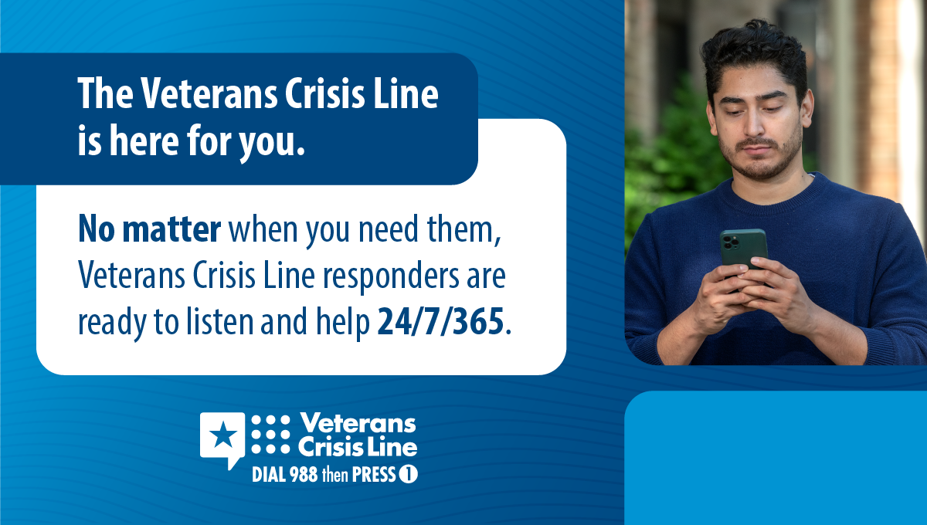  Instagram  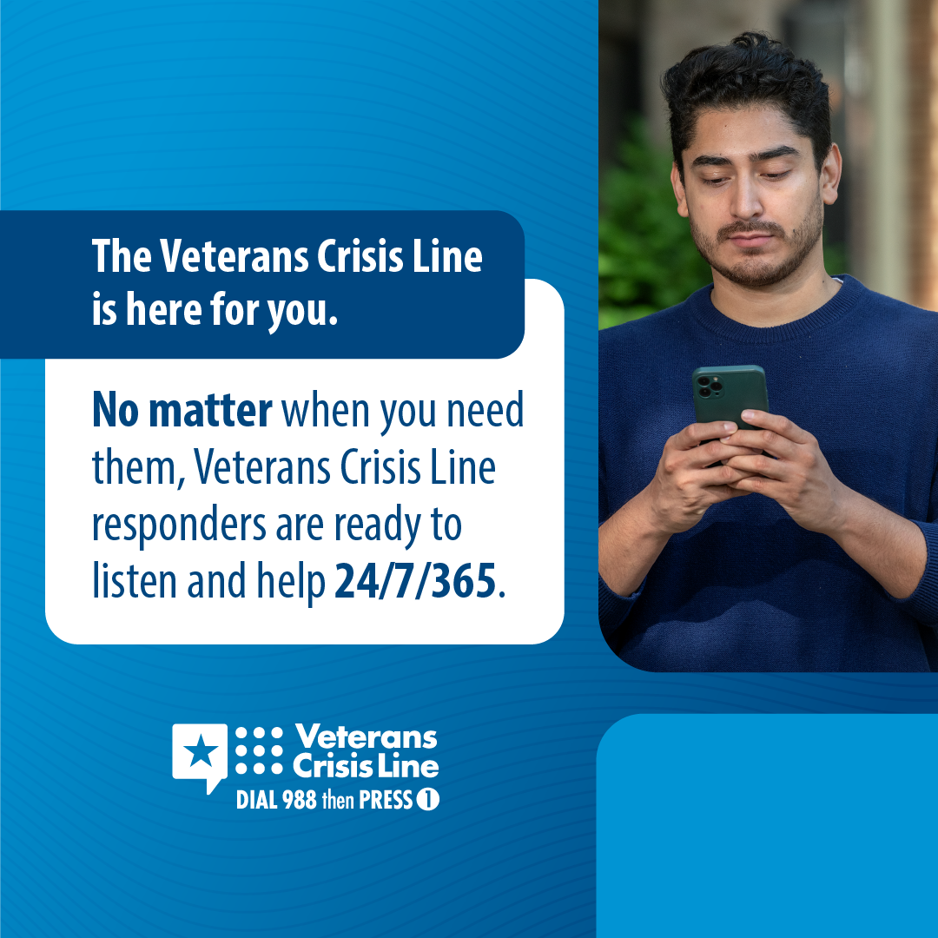
The Veterans Crisis Line’s Resource Locator can help you find VA resources tailored to your needs as a Veteran or as a friend, family member, or caregiver of a Veteran.  Use the search tool to find VA resources nearest to you: VeteransCrisisLine.net/LocalResources. | The Veterans Crisis Line’s Resource Locator can help you find VA resources tailored to your needs as a Veteran or as a friend, family member, or caregiver of a #Veteran.  Use the search tool to find VA resources nearest to you: VeteransCrisisLine.net/LocalResources. | The Veterans Crisis Line’s Resource Locator can help you find VA resources tailored to your needs as a Veteran or as a friend, family member, or caregiver of a #Veteran.  Use the search tool to find VA resources nearest to you: VeteransCrisisLine.net/LocalResources.  #SuicidePrevention #SuicideAwareness | Facebook/ X  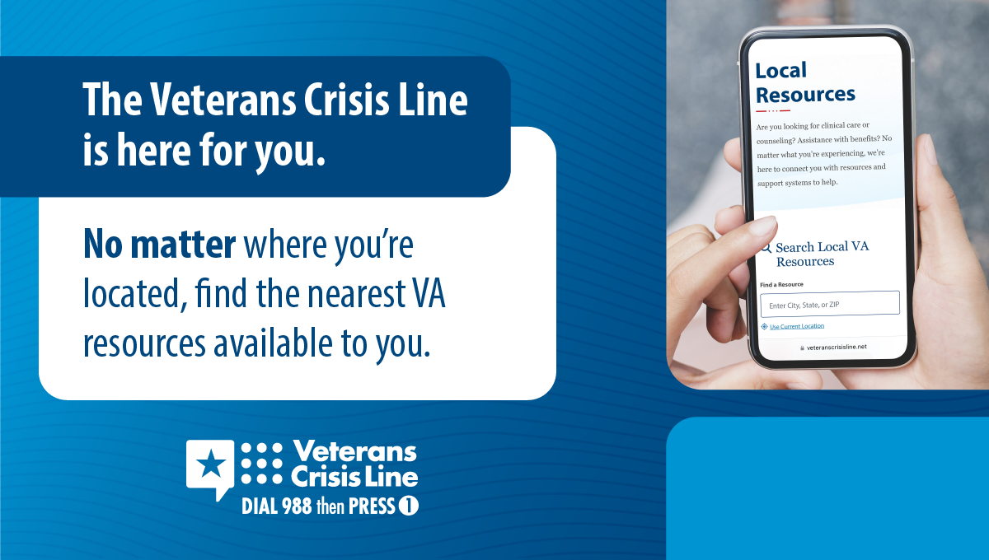  Instagram  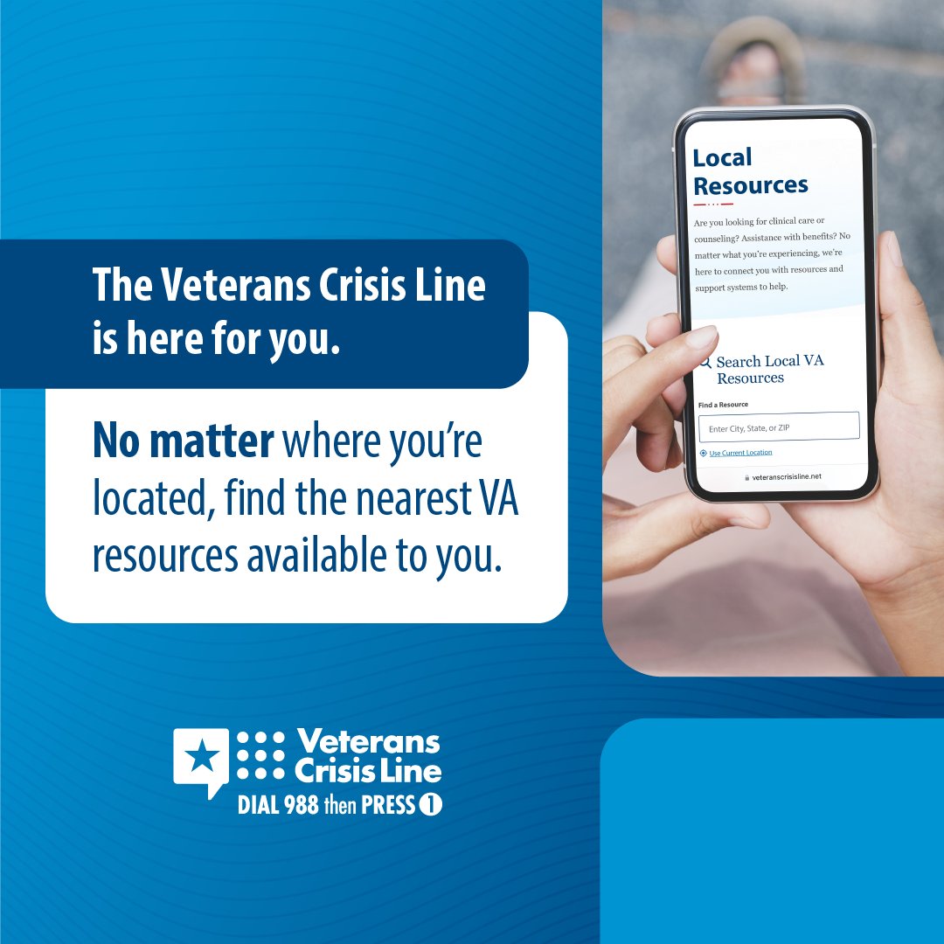
Everyone faces unique challenges in life. Take the time to learn signs of a suicide crisis to help you know when it’s time to find support for you or the Veteran in your life.  Learn more:  VeteransCrisisLine.net/signs-of-crisis. | Everyone faces unique challenges in life. Take the time to learn signs of a suicide crisis to help you know when it’s time to find support for you or the #Veteran in your life.  Learn more:  VeteransCrisisLine.net/signs-of-crisis. | Everyone faces unique challenges in life. Take the time to learn signs of a suicide crisis to help you know when it’s time to find support for you or the #Veteran in your life.  Learn more:  VeteransCrisisLine.net/signs-of-crisis.  #SuicidePrevention #SuicideAwareness | Facebook/X  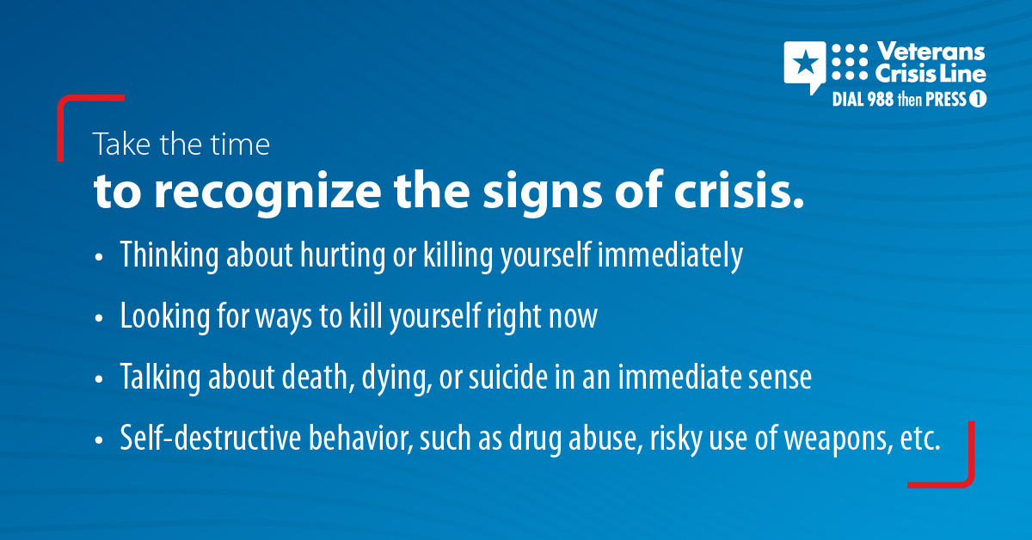  Instagram  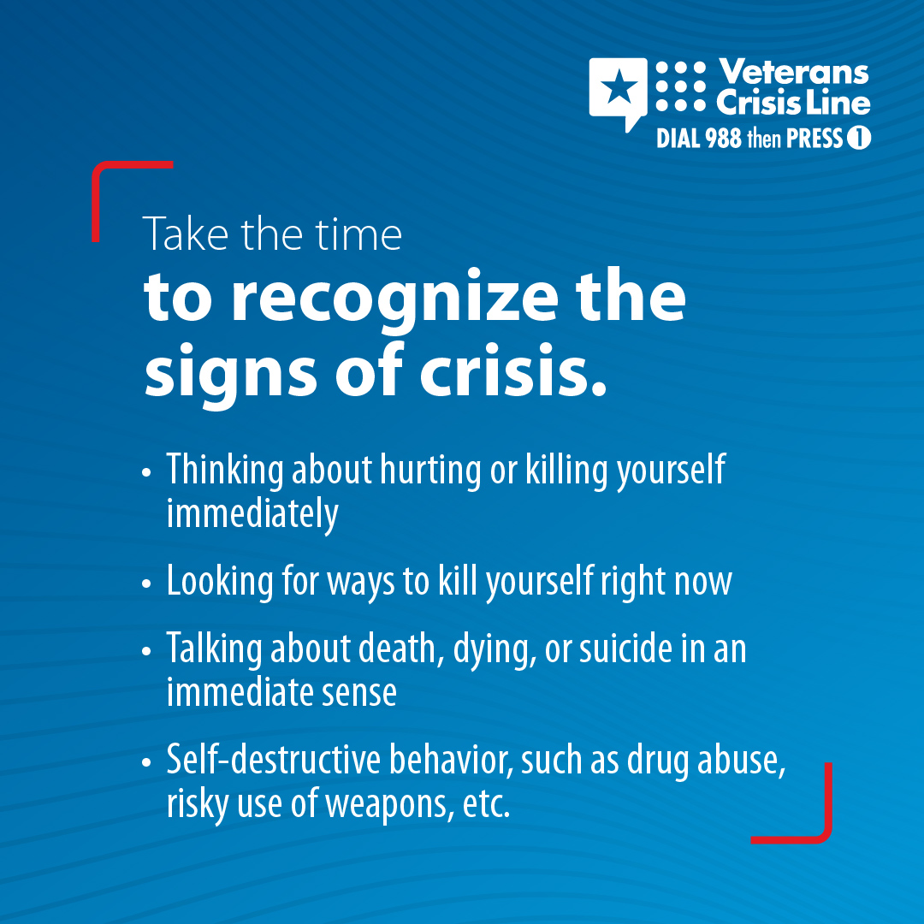
Are you having thoughts of suicide? You’re not alone, and help is here for you. Reach out to the Veterans Crisis Line today.  Dial 988 then Press 1, chat at VeteransCrisisLine.net/Chat, or text 838255. | Are you having thoughts of suicide? You’re not alone, and help is here for you. Reach out to the #VeteransCrisisLine today.  Dial 988 then Press 1, chat at VeteransCrisisLine.net/Chat, or text 838255. | Are you having thoughts of suicide? You’re not alone, and help is here for you. Reach out to the #VeteransCrisisLine today.  Dial 988 then Press 1, chat at VeteransCrisisLine.net/Chat, or text 838255.  #SuicidePrevention #SuicideAwareness | Facebook/X  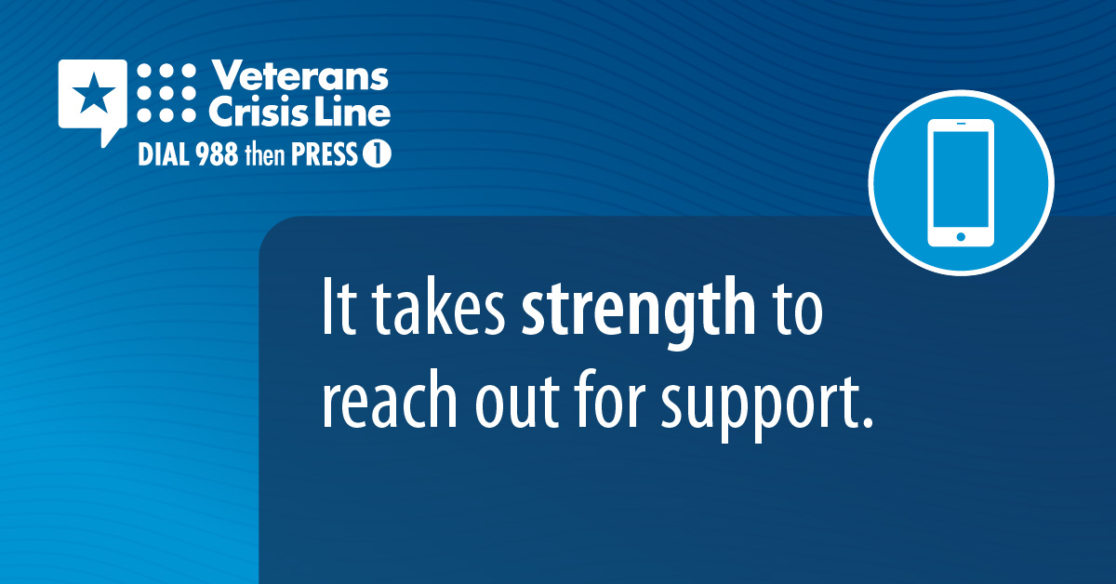  Instagram  